POLICE DEPARTMENT

“Nobility is defined as ‘greatness of character and high ethical qualities or ideals that serve a cause greater than self; faithfulness to a higher calling or purpose’. Policing is one of the most noble professions for we are the entrusted guardians of peace, justice, and democracy. This is our calling, it is our purpose, and it demands our selfless loyalty to the cause. Our citizens expect and deserve no less.” ~TM
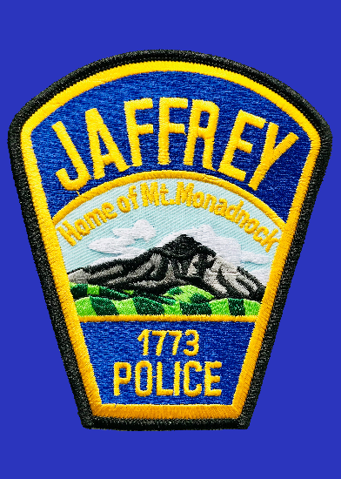
The men and women of the Jaffrey Police Department have clearly demonstrated their nobility and commitment to our community in 2020. A transition in leadership, staffing shortages, the COVID-19 Pandemic, nationwide scrutiny concerning police reform, and social justice protests, made this a very challenging and turbulent year.
The year began with the retirement of Chief William Oswalt after 27 years as a member of the police department and 13 as Chief. His dedication, contributions, and outstanding service to the Police Department and the Town of Jaffrey are to be commended. I was honored and fortunate to have worked under his leadership for the last three years. I have the utmost respect for him and I wish him and his wife Dawn happiness in their well-deserved retirement.
Staffing shortages have been our most significant internal issue all year. Officer Kelsea Ashmore, who was hired to replace Officer Swanson after she resigned to move to New Mexico in 2019, was deployed with her National Guard Unit to the Middle East just weeks after graduating from the Police Academy. She should be returning to us in April of 2021. Officer Brianna Rogers was hired to backfill the vacancy created by Chief Oswalt’s retirement, unfortunately, Officer Brian Riley had to medically retire due to an injury, hence creating another vacancy. His replacement, Officer Zach Lazzaro, is in Field Training now and scheduled to attend the Academy beginning in January of 2021. He should be ready to work patrol in May of 2021. Lastly, we now have another officer on long-term transitional duty due to a job-related injury. This has us operating three Officers short as of the writing of this report. The resulting schedule has us all filling “patrol” shifts and there are presently no “administrative” shifts for the Chief, Lieutenant, or Detective which greatly impacts our efficiency. We do not anticipate being at our full staffing allocation number of 11 sworn officers until May of 2021 at the earliest.
Shortly after I took over as Chief, the COVID Pandemic hit. It forced us to reassess how we were doing business and adjustments were made to maximize the health and welfare of our officers and community members. We were forced to temporarily close our lobby, suspend some basic services such as fingerprinting and V.I.N. checks, and minimize face to face contact with the public by utilizing a phone reporting process whenever possible. Overall, our calls for service were down and we were successful in balancing customer service with required State and Federal safety protocols.
Several police incidents, involving the use of force, around the country sparked a substantial social justice and police reform movement in 2020. Although Jaffrey was only minimally affected by this movement, we proactively addressed citizen concerns by collaborating with churches and social justice groups to share information and better understand each other’s realities vs. perceptions. A reality that we shared with these groups is that no Jaffrey Police Officer has ever been involved in a shooting or used lethal force. In addition, over the last four years we have only had one Taser deployment on a non-African American suspect, no pepper spray usage, and no baton usage. We have had only one formal complaint filed and that was not use of force or bias related.
Our efforts to address police reform concerns did not stop with our collaborations. Recognizing the need for transparency, the need to utilize industry “best practices” in delivering police services to our community, and the need to consider reasonable standards placed on us by our citizens, we proactively conducted a full review of our Use of Force policy. In addition, we reviewed “Social Justice” websites to understand current concerns and what these sites considered to be essential police reforms in reference to the requirements of police officers during encounters where force is used.
One popular police reform website listed eight “Use of Force Changes” that they demanded of all police organizations. These demands included policy requiring the use of force de-escalation, policy requiring the use of a “force continuum”, policy banning chokeholds, policy requiring warnings before shooting, policy banning shooting at vehicles, policy requiring the use of de-escalation techniques, policy requiring that alternatives are exhausted before utilizing lethal force, policy requiring a duty to intervene if another officer is using excessive force, and policy requiring comprehensive reporting. I am pleased to report that the Jaffrey Police Department’s Use of Force Policy addresses all of those demands and we have been credentialled by the U.S. Department of Justice as being compliant with Executive Order No. 13929; Safe Policing for Safe Communities.
Although it was a difficult year, 2020 was not without accomplishments and progress within the Police Department. Highlights included the promotion of Chris LaBrecque to Lieutenant and Tom Bishop to Sergeant, the rollout of new Mission, Vision, and Values Statements, minor renovations of the police station, webpage updates and revisions, and a more proactive use of our Facebook page to share information with the community. In addition, the crises encountered in 2020 ultimately helped us to strengthen relationships with our community members, churches, businesses, and schools as we worked together to keep Jaffrey a safe place to live and work.
In closing, I am very proud to be serving as the Chief of Police for the Town of Jaffrey. The men and women of our agency are fortunate to serve a community that values us and supports our mission. For that we are grateful and we promise to do our best to create and sustain a law enforcement culture in Jaffrey that is based on mutual respect, trust, and understanding.
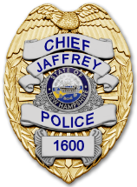 | Respectfully submitted,  Todd A. Muilenberg  Todd A. Muilenberg  Chief of Police

