POLICE DEPARTMENT

“The path of least resistance is flat and leads to mediocrity. Climb a mountain instead. Excellence resides on the summit.” ~TM

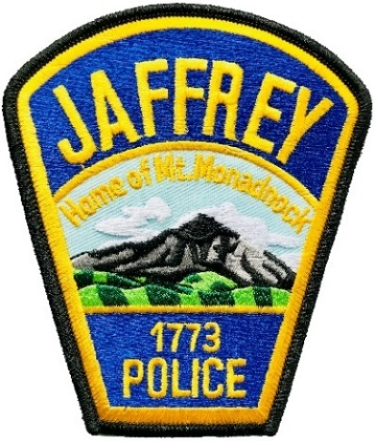
As 2021 comes to a close I think most would agree that it was another turbulent year for us all. The COVID-19 Pandemic, social unrest, and political divisiveness continued to plague our country. Although our path through 2021 was not an easy one, I believe we again prevailed in our efforts to provide outstanding police services to our community despite the adversity.
As with 2020, maintaining our full staffing allocation of 11 fulltime officers continued to be a challenge. Unfortunately, a valuable member of our team, Detective Chris Anderson, who had been on leave since 2019 due to a duty related injury, ultimately medically retired on August 31st after 18 years of service. This once again left us short-handed for the entire year. Recruiting a new officer for our vacancy has proven to be difficult as fewer and fewer people want to enter a profession that has been so highly scrutinized over the last two years.
On a positive note, 2021 saw some significant achievements for our staff members. Officer Ashmore successfully completed her military deployment and safely returned to us in April. Officer Lazzaro graduated from the Academy in May and completed his field training. Both of them have made significant contributions to our policing efforts since that time. In August, Jeremy LeBlanc was selected to assume the role of our new detective. Lastly, Denise Chatel, our Office Manager, reached 20 years of service with the Town of Jaffrey and was recognized for her outstanding work and dedication to the Jaffrey Police Department.
Fortunately, COVID-19 restrictions eased during 2021 and we were able to resume more normal patrol operations. We were also able to increase our community outreach efforts and we participated in events such as National Drug Take Back Day and McDonald’s Community Policing Night. We look forward to 2022 as we already have a few plans such as partnering with Station 16, our locally owned ice cream stand, to host a Cone with a Cop event.
Although social justice protests subsided during 2021, medical freedom protests in reference to mandated COVID-19 vaccination policies increased. Jaffrey experienced these protests at Millipore. We proactively coordinated with Millipore management, protest organizers, and adjacent property owners to ensure the people were able to exercise their civil rights in a manner that was safe, peaceful, and law-abiding. We would like to thank the stakeholders on both sides of this issue for their cooperation and willingness to respect each other’s positions.
Perhaps Jaffrey’s most talked about law enforcement issue of 2021 was the new Town Beach Parking Ordinance that restricted parking to residents only. Whereas I am pleased that a relatively minor law enforcement issue took the #1 spot, it did cause considerable consternation for non-Jaffrey residents. It required us to work closely with our Department of Public Works to ensure new signage was installed, and our Recreation Department to assist in educating citizens. In the end, many warnings were issued and only a few actual tickets needed to be written. Most Jaffrey residents were very happy to see less crowding at the Contoocook and Shattuck Beach.
Overall, our crime statistics were down for 2021. Our crime index number as reported by City-Data.com continues to be in the low 100’s where the national average is approximately 270. This speaks highly of our residents, our police department, and reinforces our premise that Jaffrey is a safe community in which to live and work.
In closing, I will repeat my statement from last year’s annual report as it still applies. I am very proud to be serving as the Chief of Police for the Town of Jaffrey. The men and women of our agency are fortunate to serve a community that values us and supports our mission. For that we are grateful and we promise to do our best to create and sustain a law enforcement culture in Jaffrey that is based on mutual respect, trust, and understanding.
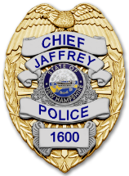 | Respectfully submitted,  Todd A. Muilenberg  Todd A. Muilenberg  Chief of Police

