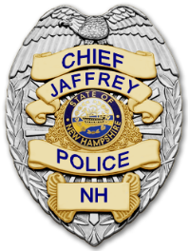 | JAFFREY POLICE DEPARTMENT  HONOR~INTEGRITY~COURAGE~RESPECT | 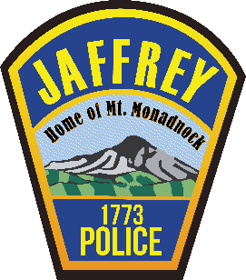
2022 Annual Report
“A standard that is easy to meet is an endorsement of mediocrity. A standard that is challenging is a catalyst for excellence.” - TM
In 2022 the Jaffrey Police Department retuned to a full sense of normalcy after weathering the effects the last three years have had on the law enforcement community. The COVID– 19 Pandemic finally eased, the social unrest that was prevalent around the country subsided, and the national calls for police reform declined after the law enforcement community made reasonable and appropriate changes to enhance support. The resilience of our officers during this difficult time was bolstered by the confidence our citizens have in our ability to deliver courteous, professional, and equitable law enforcement services to our community. Because of that, the negative effects of the last three years were minimized in Jaffrey. For this we are thankful and we look forward to continuing to earn our citizen’s support.

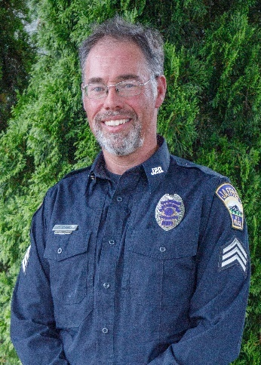
An important staffing change occurred in 2022. Sergeant Craig Tucker, known to many Jaffrey natives as “Tuck”, retired after 24-years of service to the citizens of Jaffrey. We sincerely thank him for his dedication and the many contributions he made to our community and the Police Department. He will be greatly missed. On a positive note, Officer Joe Golinski was deservingly promoted to Sergeant to fill the supervisor vacancy.

A primary goal in 2022 was to obtain and maintain a full staffing model in order to maximize our efficiency and the services we can provide to our community. This has proven to be an elusive goal. Craig Tucker’s retirement, combined with the vacancy created by a medical retirement in late 2021, and a resignation of another officer left us trying to fill three of eleven allocated positions over the course of 2022. This placed an increased burden on remaining officers and forced us to adopt less than optimal shift schedules.
Sergeant Craig Tucker Retired 2022

One of the lingering effects of the intense national scrutiny law enforcement has endured over the last three years is a rapidly shrinking candidate pool. Today, more than ever, it takes a special person with a strong character and sense of service to embark on a law enforcement career. Finding quality candidates, combined with the high standards we set for our officers, stringent testing and hiring processes, and our intensive 30-week training regimen, has made hiring and retaining new officers very difficult. We close 2022 on an optimistic note however, given that we welcomed lateral Officer Scott Merrell to our ranks in June, lateral Officer Igor Celzner in December, and we have a new recruit ready to attend the New Hampshire Police Academy in March of 2023. If all goes well, all officers will be fully trained and we will attain a full staffing allocation model in September of 2023. This will allow us to implement more proactive policing activities once again. (Fingers crossed.)
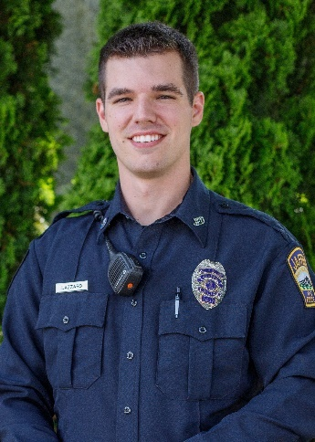
To recognize the resilience and dedication of our officers who have been tirelessly working to compensate for our staffing shortages, we re-initiated an “Officer of the Year” award program. Although the decision was difficult due to a strong pool of nominees, Officer Zach Lazzaro was the 2022 recipient. Among other criteria, Zach is the employee who “best represented our organization in 2022 and who showed the highest levels of professionalism, dedication, and productivity”. We congratulate him on this achievement and look forward to the 2023 competition.
Traffic safety was a priority for us this year and our motor vehicle stops were up approximately 70% over 2021. Officer Scott Merrell led the way in this effort. Some drivers have complained about our increased traffic enforcement activity despite the fact that over 80% of our stops resulted in a warning. Our goal is not to punish drivers, it is to encourage voluntary compliance with traffic laws and bolster safety. I occasionally have a person call to complain about being stopped and they often use the old cliché, “Don’t your officers have anything better to do?” I proudly say, “No.” I politely tell them that Jaffrey is a very safe community, our crime rates are far below national averages, and therefore we can put a stronger focus on keeping our roads safe. (They usually hang up at that point.) So you are all aware, Areavibes.com, a website that compiles FBI crime data gave Jaffrey an “A+” crime rating and reported that our overall crime rate is 74% lower than the national average. This speaks highly of our residents, our police department, and reinforces our premise that Jaffrey is a safe community in which to live and work.
Officer Zach Lazzaro “ 2022 Officer of the Year”
Another priority for us in 2022 was Community Policing. We made a concerted effort to engage and collaborate with our citizens to enhance safety, mutual respect, trust, and understanding. We delivered educational presentations to citizens and school students, collaborated with local businesses and groups such as McDonalds, Station 16, Reality Check, and Shelter from the Storm to help community members in need, and we participated in several safety-oriented community events. The list is long and space prohibits me from listing them all. What should be noted is that Officer Kelsea Ashmore received the Police Department’s “Community Policing Ribbon” for willingness to spearhead many of our outreach efforts.
The members of the Jaffrey Police Department will continue to proudly serve our community and we will set our standards high to provide excellent law enforcement services to our citizens and guests. If you have any comments, concerns, or ideas on how we can best do that, please give me a call or stop by the station. I welcome input and feedback. We work for you...
Respectfully submitted,
Chief Todd Muilenberg

