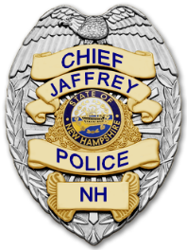 | JAFFREY POLICE DEPARTMENT  HONOR~INTEGRITY~COURAGE~RESPECT | 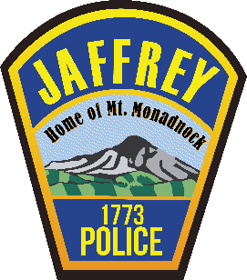
2023 Annual Report
“Do or do not. There is no try.” ~ Yoda
This was a busy year for the Jaffrey Police Department. In 2023 we handled 11227 calls for service which was almost 1000 calls more than in 2022. Not to worry. Our violent and property crimes rates continue to be far below national averages and we are amongst the safest towns in New Hampshire. I believe this demonstrates that we aren’t trying to keep Jaffrey a safe and welcoming community in which to live and work, we are doing it. Yoda would be proud.

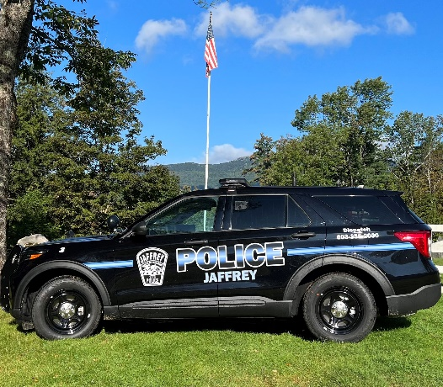
Most of the additional calls for service we logged in 2023 were motor vehicle stops related to our initiative to enhance traffic safety and reduce the number of motor vehicle accidents. Although some have complained about our stricter enforcement of the traffic laws, it should be noted that of the approximate 4400 traffic stops made by our officers in 2023, 90% of those stops resulted in warnings only. Our goal is not to penalize drivers, it is to change poor driving habits and encourage voluntary compliance with the traffic laws.
New Jaffrey Police Department Cruiser Graphics
Traffic enforcement obviously isn’t all we do. We respond to emergency and non-emergency calls for service, we conduct proactive patrols, directed patrols, and business checks. In addition, we have continued our public outreach initiative and strengthened partnerships with our schools, businesses, and private organizations that assist and support our community members. As examples, we work closely with non-profit community support organizations such as Reality Check and Shelter from the Storm. We provide Active Shooter and Safety Training to our schools and businesses in town. We routinely help instruct Driver’s Education classes for Jump Start, read to children as part of the Library Book Club, give tours of the Police Department to school groups and Scouts, sponsor “Coffee with a Cop” with our senior citizens, and partner with McDonald’s and Station 16 to conduct safety fairs. We accomplished all of these things while at the same time developing and implementing safety plans for the Town of Jaffrey’s yearlong 250th celebration. The parade and concert alone accounted for countless hours of planning and committee meetings. The celebrations were all safe and great successes. Thankfully, we have 50 years to plan for the next one. (Good luck to the Police and Fire Chiefs in 2073!)

A primary goal in 2022 (like previous years) was to obtain and maintain a full staffing model in order to maximize our efficiency and the services we can provide to our community. This has once again proven to be an elusive goal but there is light on the horizon. We finish 2023 with 10 of our 11 allocated police officer positions filled. Our newest Officers, Alex Jukoski and Stefanie Caban, successfully completed the Police Academy in November and they are presently completing field training. I am very optimistic that they will have a positive impact on our department and our community.
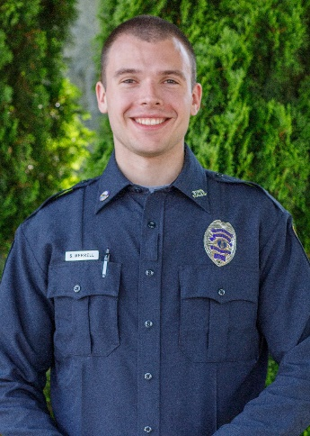
One of my favorite responsibilities as Chief of Police is to name our Officer of the Year. This officer “best represented our organization in 2023 and showed the highest levels of professionalism, dedication, and productivity”. The honor is bestowed on an officer after being nominated by fellow officers and a full administrative review by supervisors. This year the recipient is Officer Scott Merrell. Aside from his professionalism and dedication, he was at the forefront of our Traffic Safety Initiative. Of the 4400 drivers contacted in 2023, over 2000 of them met Officer Merrell in person. Of those 2000 contacts, only 1 resulted in a complaint against him and that single complaint was later determined to be unfounded after a thorough internal investigation. Well done Officer Merrell and we thank you for helping keep our community safe.
Officer Scott Merrell “2023 Officer of the Year”
2023 was not error free for the Jaffrey Police Department. In August, two days before the 250th Parade, two of our officers were involved in a serious motor vehicle accident with each other. One of our officers mistakenly pulled out in front of the other officer when turning around to stop a speeding vehicle resulting in the crash. Fortunately, our officers were not seriously injured but both cruisers sustained heavy damage. Yes, it was our fault. We had no excuses. It was my officer’s mistake. Some people were surprised when we publicly took responsibility for the accident in a press release. They should not have been. Integrity is one of our core values and you have my promise that we will uphold our own values and accept responsibility for our mistakes. That is the only way we can establish the trust of our community members. Although costly, out of this bad situation, some good came. While replacing our cruisers we designed a new, updated, cruiser graphic package (see photo above). This new look has been overwhelmingly approved by commenting citizens and will be utilized on future cruisers.
The members of the Jaffrey Police Department will continue to proudly serve our community and we will set our standards high to provide excellent law enforcement services to our citizens and guests. If you have any comments, concerns, or ideas on how we can best do that, please give me a call or stop by the station. I welcome input and feedback. We work for you...
Respectfully submitted,
Chief Todd Muilenberg

